**PROJECT NAME: FLIPKART CLONE**

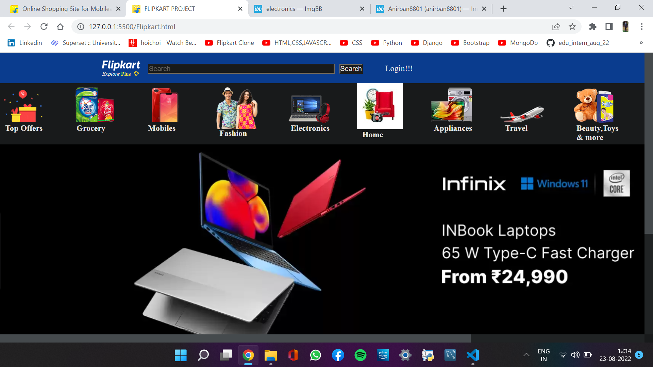

**Overview:** It is an e-commerce website which consist of all kinds of products such as electronic gadgets, fashion, shoes, clothing, grocery, fashion etc.

**Goals:**

1. **Homepage: -**

This page will be the first page where we will have the overview of Flipkart with maximum number of products being shown along with the search bar, sliders to slide down, top offers visible on the page. At the bottom of the page there will be contact Flipkart option, about Flipkart and their privacy policy.

1. **Search Page: -**

From homepage when we search a topic or click on a product then we will be redirected to this page where we will see lots of options w.r.t the searched item or product clicked, available along with the choosing the priorities you want , price within which you want the and the rating based on which you want the product will be available in this page.

1. **Details Page: -**

From Search page if we click on a product then we will be redirected to this page where all details will be provided about that specific product throughout the page.

1. **View Page: -**

This page will be shown if the customer put some products in his/her cart. Customers can come back later and view this page.

1. **Payment Page: -**

After choosing a specific product that customer want, proceed to buy will give these following options from where you can choose any one.

* Options: -
* UPI (PhonePe, GooglePay)
* Credit/Debit/ATM Card
* EMI
* Cash On Delivery

1. **Thank You Page: -**

After successful payment, a thank you page will be shown which will indicate that the order is placed successfully.

**Technologies Used:**

**Front End:**

* HTML
* CSS
* JAVASCRIPT
* BOOTSTRAP

**Back End:**

* PHP
* MySQL (Data Storage)